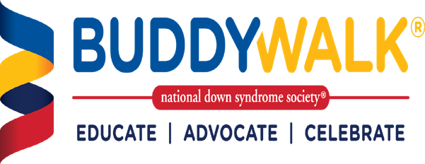

# Washington Park,

# Springfield, IL

# 9/24/23

**2023 Registration Form**

**Please complete this form and mail to**

***LLDSS Buddy Walk***

c/o Lynn Evans

4942 Turkey Run Rd, Sherman, IL 62684

**TO REGISTER ONLINE GO TO**

# [www.lldss.org/events](http://www.lldss.org/events)

Name: Street Address: City: State: Zip: Phone: e-mail:

**YES!** I/We will be there to help raise awareness and promote inclusion for individuals of all abilities.

# Individual Registration - $10/person # Children (2-12 years old) - $5/child # Children < 2 year old – **Free**

# Individual with Down syndrome– **Free Total all reg $**

**…at a glance**

Since 1995, the Buddy Walk® has been the premier advocacy event for Down syndrome in the United States. It is also the world’s most widely recognized public awareness program for the Down syndrome community. The flagship New York City Buddy Walk® attracts participants from coast to coast each year.

**Total Registration = $**

# of T-shirt sizes for participants (included with registration): Adult: S M L XL XXL

Child: XS _S _M _L _­

**Payment:**

❑ I have enclosed a check for $ payable to: ***“LLDSS”***

100% of funds raised through LLDSS Buddy Walk stays right here in the community and helps to fund therapeutic and educational programming opportunities for individuals with Down syndrome.

**Volunteer:**

❑ Please contact me about volunteering on the day of the event.

**Waiver for walkers**:

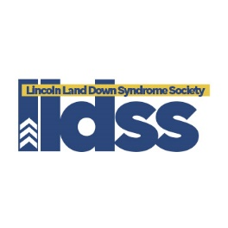I the undersigned assume full and complete responsibility for any injury or accident, which may occur during my participation in LLDSS Buddy Walk or while I am on the premises of the event. I hereby release and hold harmless LLDSS, it’s officers, and volunteers. I also hereby grant LLDSS permission to use my likeness in a photograph, video, or other digital media on any and all websites, social media, or publications belonging to LLDSS.

Signature: Date: